**Name: JOBIN T J**

**Roll No:7**

**Batch:MCA-B**

**Date:7-4-2022**

**NETWORKING & SYSTEM ADMINISTRATION LAB**

**Experiment No.: 1**

**Aim**

Familiarization of Hardware Components in a Computer.

**Procedure**

Network Interfaces Card (NIC)

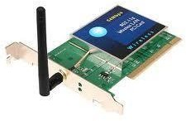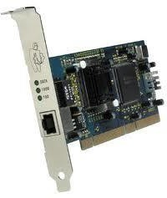NIC**:** is a device installed in a computer, printer, or any other network component so they can be connected to a network.

**Hard Disk Drive**

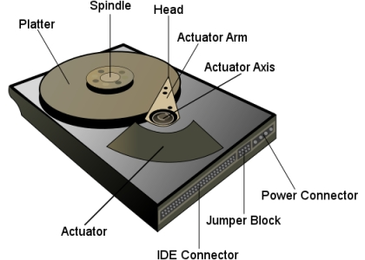

A hard disk drive (HDD) is a non-volatile storage device which stores digitally encoded data on rapidly rotating platters with magnetic surfaces. Just about every new computer comes with a hard disk these days unless it comes with a new solid-state drive. Typical desktop hard disk drives store between 120 and 400GB, rotate at 7,200 rpm, and have a madia transfer rate of 1 Gbit/s or higher. Hard disk drives

are accessed over one of a number of bus types, including parallel ATA(also called IDE), Serial ATA (SATA), SCSI, Serial Attached SCSI, and Fibre Channel.

**ROM Memory**



ROM stands for a type of memory chip that can be read from but not written to.

In other words, it's a form of data storage that can't be changed after being programmed.

It's sometimes called "non-volatile" memory because the stored information will remain even when not powered up or in use.

ROM is often used to store a computer's basic start-up instructions and certain types of data, such as your car's onboard computer system and a calculator's data tables

**Power Supply**



A power supply is an electrical appliance that provides the necessary power to operate a computer.

Computers are powered by electricity, and the power supply converts the alternating current (AC) from the electric outlet into direct current (DC).

The power supply in a computer can be an internal or external component.

It’s important to make sure your power supply is functioning properly

**Hub**

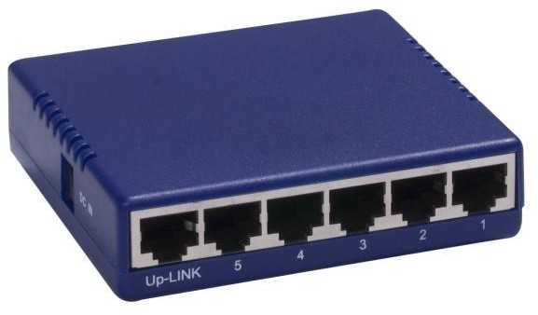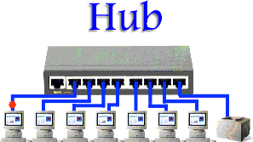

is a device that contains multiple ports to connect multiple computers or network devices to each other. When a computer transmit data through a hub, the hub will broadcast the data to all other computers attached to it.Broadcast: the data are sent to every device on a network

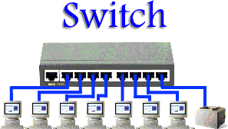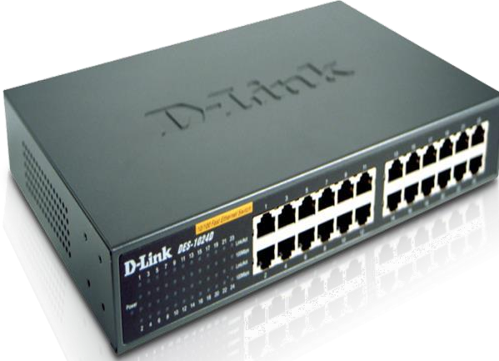**Switch**

**Switch**: is a device that contains multiple ports to connecmultiple computers or network devices to each other. Unlike hub, switch can send the data to only the destined computer.

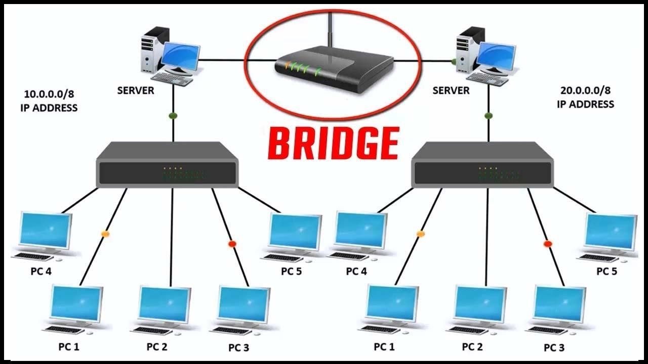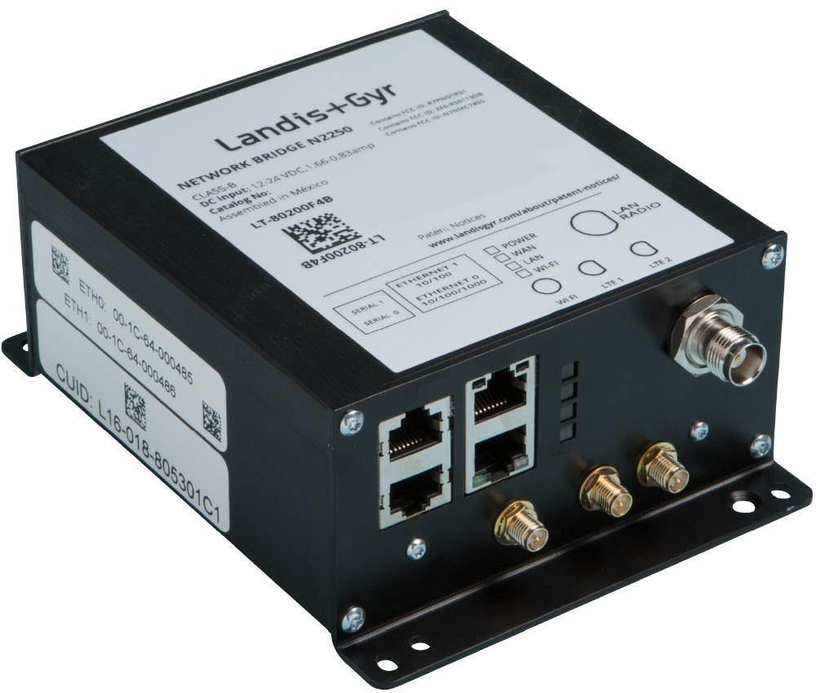**Bridge**

**Bridge**: we can say that the bridge is the old version of the switch, where the

bridge works almost like the switch

**Router**

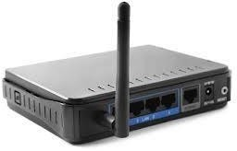

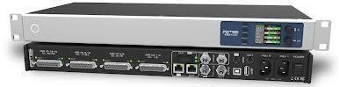

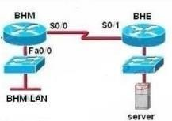

Router:is a device whose primary purpose is to connect two or more networks and determine the next network point to which the data should be forwarded toward its destination

**Solid State Drive (SSD)**

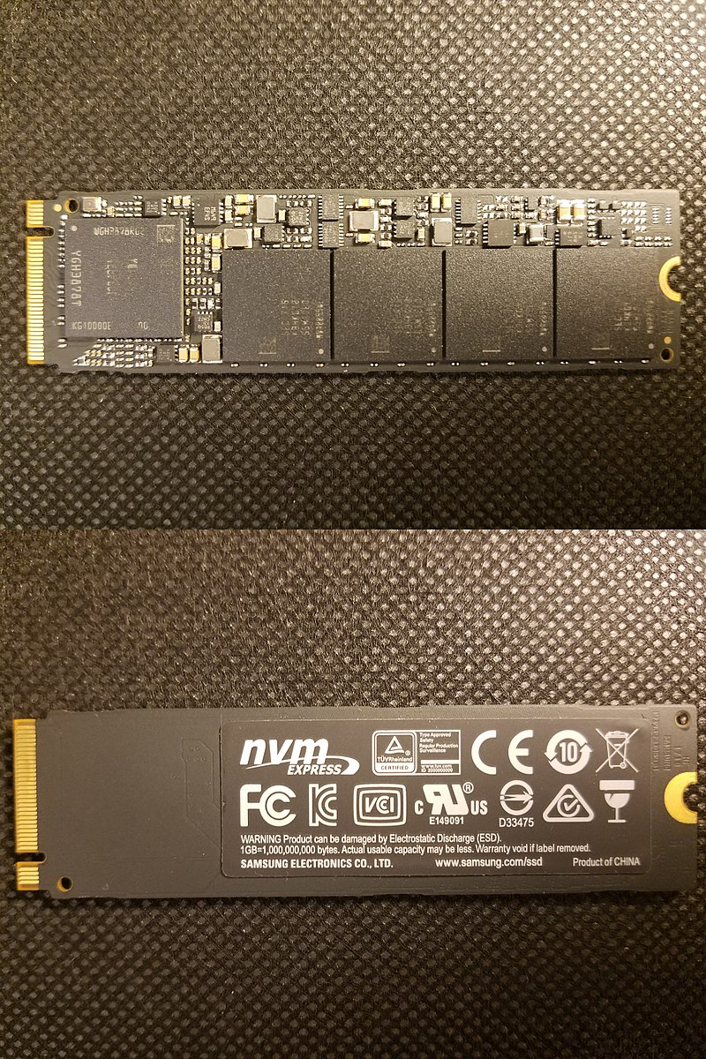

A solid-state drive (SSD) is a new generation of storage device used in computers. SSDs use flash-based memory, which is much faster than a traditional mechanical hard disk. Upgrading to an SSD is one of the best ways to speed up your computer. Learn how SSDs work and how to keep them optimized with a specialized performance-boosting tool

**Optical Drive**



Optical Drives are used in PCs to read and write CDs and DVDs.

The optical drive reads the data from the disc, which can then be transformed into a digital file that is readable by the computer.

This makes it easy to backup files, play music or movies, or copy data from one disc to another.

The term "CD" refers to Compact Discs, which are the most common type of optical drive on modern computers.

**Heat sink.**

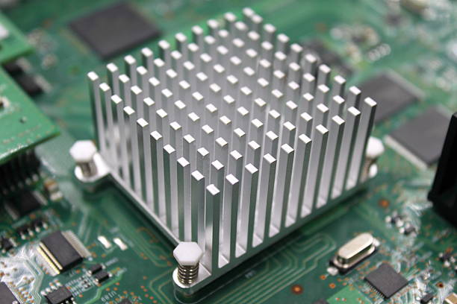

This is a passive piece of hardware that draws heat away from components to regulate/reduce their temperature to help ensure they continue to function properly. Typically, a heat sink is installed directly atop the CPU, which produces the most heat among internal components

**Processor**

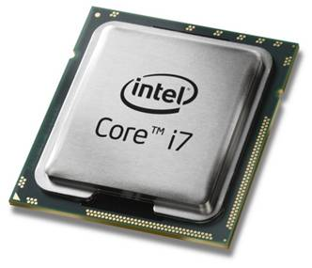

The processor, also called the microprocessor or CPU (for Central Processing Unit), is the brain of the PC. It performs all general computing tasks and coordinates tasks done by memory, video, disk storage, and other system components. The CPU is a very complex chip that resides directly on the motherboard of most PCs, but may sometimes reside on a daughtercard that connects to the motherboard via a dedicated specialized slot.

**Random Access Memory**

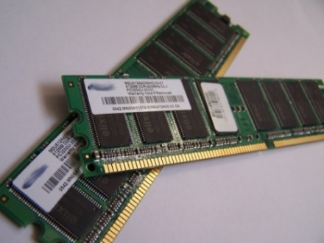

Random access memory (RAM) is fast-access memory that is cleared when the computer is power-down. RAM attaches directly to the motherboard, and is used to store programs that are currently running. RAM is a set of integrated circuits that allow the stored data to be accessed in any order (why it is called random). There are many different types of RAM. Distinctions between these different types include: writable vs. read-only, static vs. dynamic, volatile vs. non-volatile, etc.